**COIT20270**

**App Development for Mobile Platforms**

**Term – 2, 2020**

**Assignment 3**

**Report**

**Lecturer: Mohammed Mazid**

**Tutor: Kaixiang Zhu**

**Prepared By:**

**Bishal Budhathoki**

**12116421**

Table of Contents

1. Problem Description: 3

2. Best Application that has been Working on the similar / same Problem: 3

3. Strength and Weakness 3

4. Better Solution Proposal: 4

5. Points of Difference for the given solution: 8

6. Possible Target Market: 8

7. Strategies to gain the target market: 9

8. Ethical Concerns: 9

References: 10

# Problem Description:

After living here in Ashfield for over 1 and half year and travelling with unit owner’s car mostly and along with research online to confirm the issues that this suburb has is the Parking spot and the parking management with it. The roads are mostly busy and there is no rule to park on the roadside and the time given to park is always full. The roads that are not busy are very narrow that can be used for only a vehicle at a time means no park. Where the parking is available, needs to pay hefty amount for it and some apartment that gives parking for external resident can park only for 2 hours or less else again the fine is there.

# Best Application that has been Working on the similar / same Problem:

After searching for the apps around Google Play Store, Microsoft Store and Amazon App Store that works on the Parking spot finding and delivering it to the drivers around Australia, I found few apps around Google Play Store. Microsoft store and Amazon App Store lacks apps around parking spot. The apps that I found more promising are Wilson Parking, PayStay, Divvy, Parkhound: Find & Book Local Parking. And among these, I found Parkhound, Divvy, Wilson Parking as best among other found working to solve the issue with the parking.

# Strength and Weakness

Pros:

|  |  |  |
| --- | --- | --- |
| Application | Features | Layout |
| Wilson Parking | * 400+ car parks are available * Pre-booking for the parking spot is available * Direction to the closest park or navigation to the parking spot is provided | Modern, Clear and Simple |
| Divvy | * Lists of all possible parking spot with the cost per day is provided for the user * Long term Parking booking feature is available * Filtering the requirement for the parking is a very nice feature | Theme colour sky blue, many widgets |
| Parkhound | * Finds cheap parking spot possible in the cities * Moneyback Guarantee with 7-day support for the issue facing users * Empty space owner can rent out the space if any and earn * 40,000+ over spot around cities | Clear, theme colour teal green very subtle, modern |

Cons

|  |  |  |
| --- | --- | --- |
| Application | Features | Layout |
| Wilson Parking | * No public car park spot available in the app * Not all older devices not supported by the app * Lots of payment issues from the user review left in play store review | Very simple and mostly everything on a single screen, user can select the wrong parking spot and pay for it |
| Divvy | * Coming soon spot confusing for the user and try to get that spot which is not available yet * Cannot cancel the pre-booked spot which the user has not even used * No correct spot to park is displayed and users are confused where to park and sometime parks on the wrong spot. | Old UI style design, more widgets in a single screen |
| Parkhound | * Support received are not good for most user * No communication between user, spot owner and the app support making users losses the platform and move to another | No issue |

# Better Solution Proposal:

After going through the above listed app specification, UI and the user reviews, although it solves most of the parking spot issue, they are more specific for city or busy and populated city area. So, this still gives issues for suburbs that are far from the city and all these app does not provide public parking spot. Hence here is my proposal for the solution that all above app could not cover and solve the public parking spot issue that the Ashfield community and other similar community are facing.

1. Using sensors to know the parking spot is taken or nor for the public parking and using that to provide the public parking spot data to the user, better charge a monthly or weekly subscription fee to use that service.
2. Now for this, take consideration to all the suburbs that has more issues on car parking and are far from city too and are to be facing the issue soon.
3. Exact location can also be provided with the sensor use.
4. Using locals of each specific suburb to take cover on the sensor check and the user complaint for each suburb
5. No booking for the public parking spot and considering the rules placed on specific roads are not broken.

Now here is the app UI that I would purpose for the solution app and this does not represent the final UI. This is a demo and final version can be totally different. Flow of UI is as follow:

1. Whenever the user opens the app, figure 1 loads up. This screen is a login page with an option to Sign up if new user. For login Username and password is taken and upon selecting sign up button, the user is taken to the home screen figure 7.
2. User can also opt to login in using Facebook and a separate screen pops up for Facebook login. And taken to Home screen Page.
3. If user opt to sign in via Sign in button, user is taken to sign in page. It accepts Name, email and password from the user and using those data user can sign up. Upon selecting continue button the user is taken to the Payment page Figure 3.
4. All the require fields like Name, Card number, Expiry Date, CVC number, Country, City, Address is taken from the user and upon selecting Apply button the account is created for the user and auto logged in and taken to home screen. There is an option to cancel if user do not feel like to give payment detail at that time.
5. User will again be taken to the home screen but upon selecting the parking spot that is paid will be required to fill the Payment details.
6. If the user swipe right, then Panel screen figure 6 is opened and upon again swiping right Figure 5 panel screen is opened. Figure 5 panel menu helps user to view the map and access panel menu at a same time.
7. If the user selects the parking spot, then the user is navigated to the parking spot like in figure 4.
8. In the map user can still view the different places around the location.
9. There is an option called Public Parking spot and it will display only the available parking spot that is available, and all those data are achieved using the sensors.
10. User can contact us if on an issue or suggestion.
11. Privacy policy and about us are provided to the user so that everything is clear with the users.

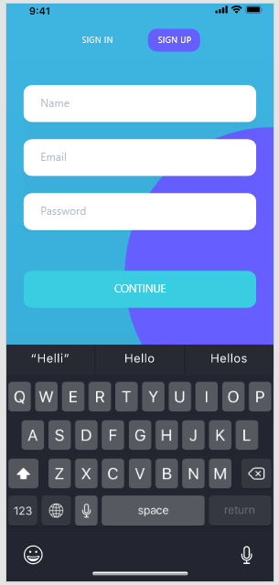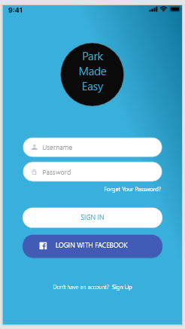

Figure 1: Login/Sign in Page Figure 2: Sign Up Page

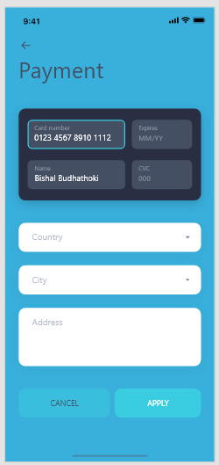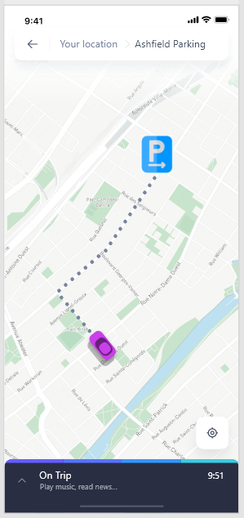

Figure 3: Payment Setup Page Figure 4: Parking Spot Navigation Page

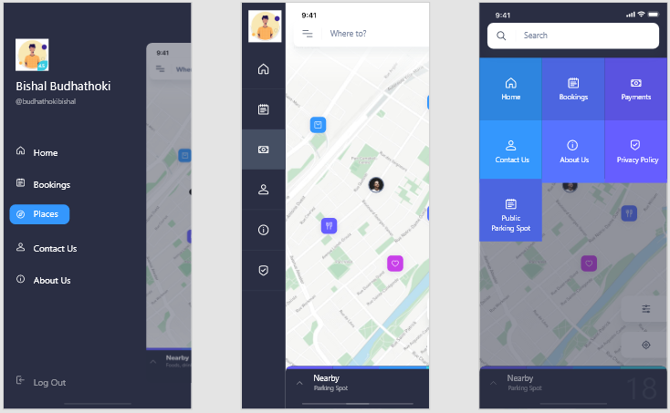

Figure 5: Panel Menu Figure 6: Reduced Panel Figure 7: Home Screen Page

For Map View

# Points of Difference for the given solution:

From the existing app and the given solution here is what it makes a difference:

1. Existing app is leaner towards being money oriented and paid parking spot, the purposed solution covers the free public parking spot.
2. Use of sensor knows when the spots are taken or free, so this clears the issue of not knowing which is the spot for the user.
3. Locals are getting employed for the fast customer service so better service and issue resolves faster.
4. No booking hassle for the public parking spot.
5. All most all suburbs can be covered.

# Possible Target Market:

Target market is a group of targeted users/consumers at which a product/service is aimed. Not knowing the target market can cos fortune for the company (Kenton, 2020). The target market remains same for the purposed app with addition to the more suburb drivers and user that do travel other than cities. That mean addition of local community people in the app that can help generate more revenue than possible it was before. So, the proposed solution does not hamper the existing market but adds more users to the existing database of users.

# Strategies to gain the target market:

Now, there is the previous market that is already for this platform. We need more people to use the proposed app and for this new proposed solution and for this there is certain specific people that needs to be targeted and those are away from city suburbs.

Customised marketing is more lean towards relationships between the customer being the app user/driver and the supplier the app developer/owner as high demands of this service is enough to justify huge marketing and sales being the app and subscription or service fee being focused on each user (Target Marketing: Four Generic Target Marketing Strategies, 2020).

Here the customers’ pain points are defined that is public parking and away from city suburbs parking. And this can be more specific per user (Garces, 2020).

Now here knowing the customers pain point and the fact that we are targeting the customer we can send in app notification for the app for the existing users, for new users we can use ads in the social media app where the data of people who owns the car, uses Uber services or looking for the car and more data similar to it can be used and these data can also be bought from the third party. We can also now use the influencer to target the market. Every influencer can not be the part of it as every one of them has their own set of fans following that does not fulfill the marketing target (What is Influencer Marketing? An in Depth Look at Marketing's Next Big Thing, 2020).

# Ethical Concerns:

Despite the increase in demand of the app for the parking spot, there has been subjected to many ethical issues and some are (Ethical Issues Facing Uber, 2020):

1. Driver/User Safety: They should be able to move out the vehicle from the spot when the user want and if any interruption is to be occurred at the parking spot or around it the user should be inform
2. Car Security: The user that park the car in paid spot should have the safety for their car.
3. Privacy: Privacy is the huge issue when everything goes digital. The user’s location, their profile data are the major privacy concern and should be used with the user known consent else should not be used for any purpose.
4. Data security: Data obtained from GPS, their profile, credit card, sensors and more are to be protected and data server should be fully equipped for any sort of failures.

# References:

Homely.com.au. 2020. Ashfield Guide, Moving To Sydney (Greater) - Homely. [online] Available at: <https://www.homely.com.au/ashfield-ashfield-sydney-greater-new-south-wales> [Accessed 12 October 2020].

Play.google.com. 2020. Divvy. [online] Available at: <https://play.google.com/store/apps/details?id=com.divvyparking> [Accessed 14 October 2020].

UKEssays.com. 2020. Ethical Issues Facing Uber. [online] Available at: < https://www.ukessays.com/essays/business/uber-ethical-issues.php?vref=1> [Accessed 14 October 2020].

Garces, K., 2020. 9 Marketing Strategies To Increase Sales In 2020 - Unlimited Graphic Design Service. [online] Unlimited Graphic Design Service. Available at: <https://penji.co/2020-marketing-strategies-increase-sales/> [Accessed 14 October 2020].

Kenton, W., 2020. Target Markets: What Everyone Should Know. [online] Investopedia. Available at: <https://www.investopedia.com/terms/t/target-market.asp> [Accessed 16 October 2020].

Play.google.com. 2020. Parkhound: Find & Book Local Parking. [online] Available at: <https://play.google.com/store/apps/details?id=com.parkhound.marketplace> [Accessed 14 October 2020].

Your Article Library. 2020. Target Marketing: Four Generic Target Marketing Strategies. [online] Available at: <https://www.yourarticlelibrary.com/marketing/target-marketing-four-generic-target-marketing-strategies/13400> [Accessed 14 October 2020].

Influencer Marketing Hub. 2020. What Is Influencer Marketing? An In Depth Look At Marketing's Next Big Thing. [online] Available at: <https://influencermarketinghub.com/what-is-influencer-marketing/> [Accessed 14 October 2020].

Play.google.com. 2020. Wilson Parking. [online] Available at: <https://play.google.com/store/apps/details?id=au.com.wilsonone> [Accessed 14 October 2020].